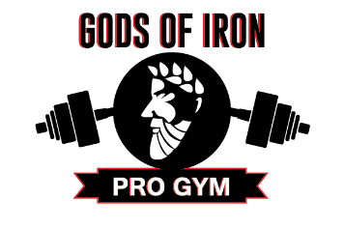
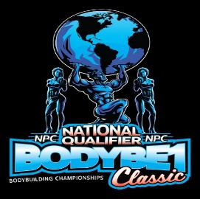
TRI-CITY CLASSIC
PRO-AM
Olympia Qualifier, National Qualifier, EXPO,
Fitness Model Competition and MORE
IFBB – Men’s Physique, Men’s Classic Physique, and Figure
NPC – All Classes
April 12th & 13th, 2024
SPONSORSHIPS
Title Sponsor -$5000 VIP Sponsor - $3500
-OFFICIAL SPONSOR -Radio/Newspaper Ads
-TV Promotion -Business Logo on printed posters/flyers/
-Radio/Newspaper Ads Advertisements
-Business Logo on Billboard -Business Logo on Billboard
-Large Business Logo on top of Backdrop -Business Logo on t-shirts
-Official Overall Trophy Presenter (IFBB PRO) links, event emails, website, social media
-Business Logo on all printed posters/flyers, ads -Business Logo on backdrop
-Business Logo on t-shirts, links, emails, website, -Trophy Presenter
Social media -Booth and 2 booth badges at all events
-Vendor booth and 3 booth badges at all events -Tickets – 2 VIP access tickets for all events
-Opportunity to speak on stage to promote -Recognized by show Emcee during competition
Business (2 minutes)
-Recognized by show emcee during competition Trophy Sponsor - $750
-Tickets – 4 VIP access tickets (x4) to all events , -Business Logo on Posters/flyers
(fit model) NPC, IFBB Bodybuilding, EXPO). -Business Logo on t-shirts
-Appearance on Table Talk with Roland Podcast -1 booth @ 2 booth badges at BB event
To promote your business -Banner at event
-Logo & links on event emails, website, Business Sponsor - $1500 social media
-Radio/Newspaper Ads -Recognized by show Emcee during
-Business logo on posters/advertisements/flyers competition
-Business Logo on t-shirts, links, emails, website, -1 general admission ticket for NPC prejudging
Social media and 1 general admission ticket for NPC Finals -Recognized by show emcee during competition
-Trophy Presenter Support Sponsor - $250
-1 Booth & 2 booth badges at BB event and EXPO -Business Logo on posters/flyers
-Tickets – 1 VIP access ticket for all events -Business Logo on t-shirts

Vendor Sponsor- $450
-Business Logo on posters/flyers T-shirt Sponsor -$100
-Business Logo on t-shirts -Name on back of t-shirt
-1 Vendor booth & 1 access badge at EXPO
and Bodybuilding event BOOTH only
-1 general admission ticket for NPC Pre-judging -$200 per day plus $100 for 2nd location on
same day.VENDOR Booth Only -

